Subject: Invitation to Erasmus+ Blended Intensive Programme (BIP) – Cyber–Future
Body:
Dear International Erasmus Officers,

We are pleased to inform you about an upcoming academic event that we believe will be highly valuable for Master’s students whose studies are related to cybersecurity and emerging cyber technologies.
The Faculty of Computer Science and Engineering, Ss. Cyril and Methodius University in Skopje, will organize its first Erasmus+ Blended Intensive Programme (BIP) entitled: Cyber–Future: Turning State-of-the-Art Research Results into Future Cyber-Training
This event is organized within the framework of the Erasmus+ Programme with BIP registration number: 2024-1-MK01-KA131-HED-000223734-2
The Blended Intensive Programme will be delivered through two complementary components. The online component will take place from 23 March to 17 April 2026, during which students will participate in virtual lectures and academic activities. This will be followed by the on-site component, scheduled for 20–24 April 2026, hosted at the Faculty of Computer Science and Engineering, Ss. Cyril and Methodius University in Skopje, North Macedonia.
All relevant information regarding the programme structure, application procedure, and important deadlines is available on our official webpage:
👉 https://bip.finki.ukim.mk
We kindly invite you to share this opportunity with your Master’s students and encourage them to apply.
Participation will be supported through the Erasmus+ Blended Intensive Programme (BIP) mobility scheme. Students who successfully complete the programme will receive 3 ECTS credits.

Important Information for Partner Institutions
As an Erasmus partner institution, we kindly ask you to:
- Insert the name and ID of the BIP when registering your students for participation.
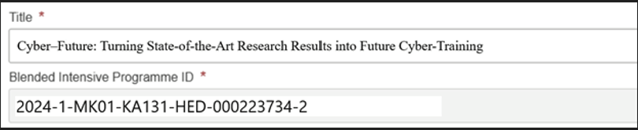

- Encode the mobilities in the Beneficiary Module, ensuring that they appear in our account so that the mobilities are recognized and validated.

Should you require any additional information, please do not hesitate to contact us at:
📧 bip.finki@finki.ukim.mk

We look forward to welcoming your students to Skopje.

Best Regards,
BIP Organizers
Faculty of Computer Science and Engineering
Ss. Cyril and Methodius University in Skopje
Skopje, North Macedonia

